



Create different types of indexes in a MySQL database.
LAB MANUAL

Disclaimer: The content is curated from online/offline resources and used for educational purpose only
Create different types of indexes in a MySQL database.
Objective:
The objective of this lab is to demonstrate how to create different types of indexes in a MySQL database. Specifically, you will learn to create:
- A single-column index.
- A multi-column index.
- A unique index.
Problem Statement:
Given a table Employees with the following columns:
employee_id (Primary Key), first_name (String), last_name (String), email (String), department (String), salary (Decimal),
The task is to:
- Create a Single-Column Index on the last_name column.
- Create a Multi-Column Index on the department and salary columns.
- Create a Unique Index on the email column.
Requirements:
- MySQL (or MySQL Workbench).
- Access to MySQL command-line interface (CLI) or MySQL Workbench to run SQL queries.
Procedure:
Step 1: Start MySQL Server:
Open the command line or terminal.
On Windows: Use MySQL Workbench or run the mysql command.

Step 2: Create Database (if not already created)
First, ensure you have a database where the Employees table will exist.
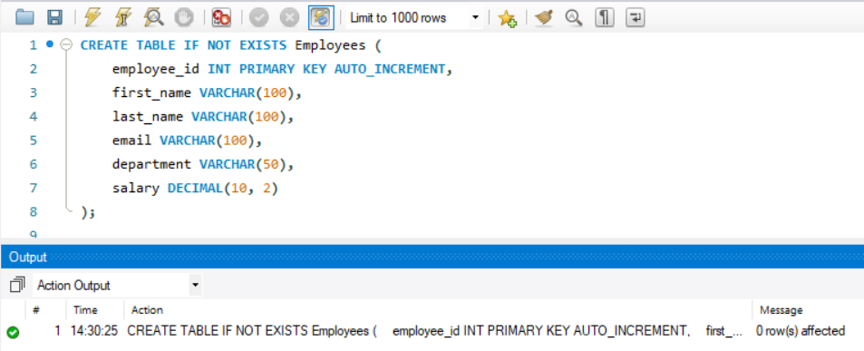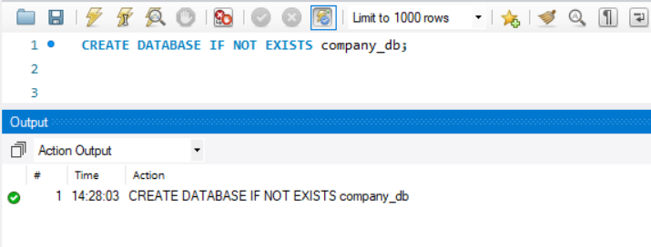

Now we creates a database company_db and switches to it.

Step 3: Create Employees Table
Before creating indexes, ensure that the Employees table exists. If not, create it.

This statement creates the Employees table with the relevant columns.
Step 4: Insert Sample Data
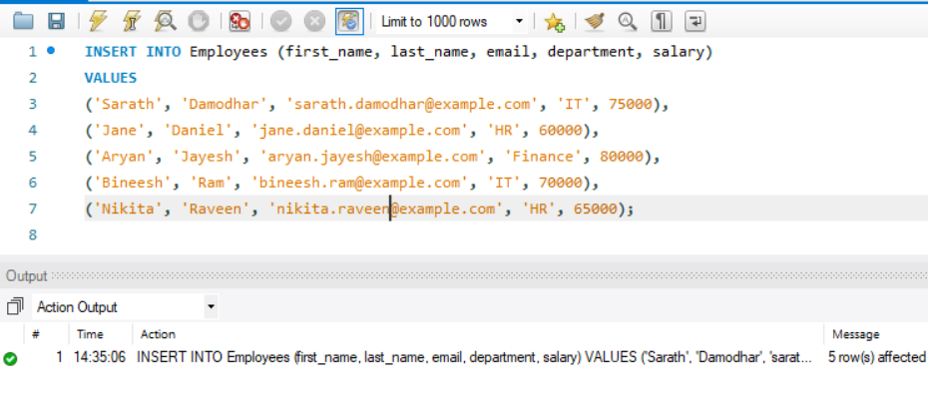
Inserted 5 records into the table.

Step 5: Create a Single-Column Index on last_name
To create a single-column index on the last_name column, use the following SQL:
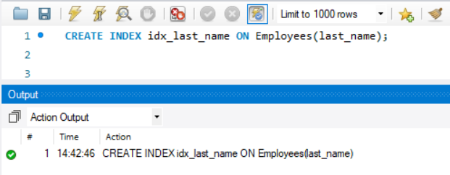
CREATE INDEX is the MySQL command used to create an index. idx_last_name is the name of the index. (You can choose any name).
ON employees(last_name) specifies that the index will be created on the last_name column of the Employees table.

Purpose of Single-Column Index:
This index helps speed up queries that search for employees based on their last name. For example, a query like SELECT * FROM Employees WHERE last_name = 'Daniel' would benefit from this index.

Step 6: Create a Multi-Column Index on department and salary
Now, create a multi-column index on the department and salary columns:

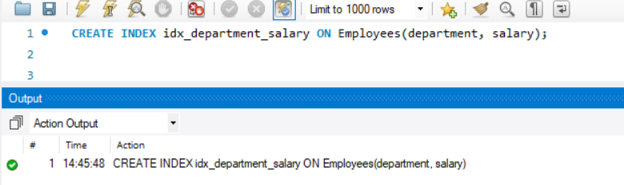

CREATE INDEX is used again to create an index. idx_department_salary is the index name. ON Employees(department, salary) means this index will cover both the department and salary columns.
Purpose of Multi-Column Index:
This index is useful when queries filter based on both department and salary. For example, SELECT * FROM Employees WHERE department = 'IT' AND salary > 70000 will benefit from this multi-column index.

Step 7: Create a Unique Index on email
Finally, create a unique index on the email column to ensure that each email in the Employees table is unique:
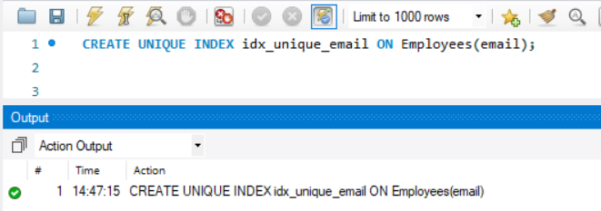

CREATE UNIQUE INDEX creates an index with a uniqueness constraint, ensuring that no two employees can have the same email. idx_unique_email is the index name.
ON Employees(email) specifies that the index will be created on the email column.
Purpose of Unique Index:
A unique index ensures data integrity by preventing duplicate emails. For example, if you try to insert an employee with an existing email, MySQL will throw an error.

Step 8: Verify Indexes
To verify that the indexes were created successfully, you can use the following command:

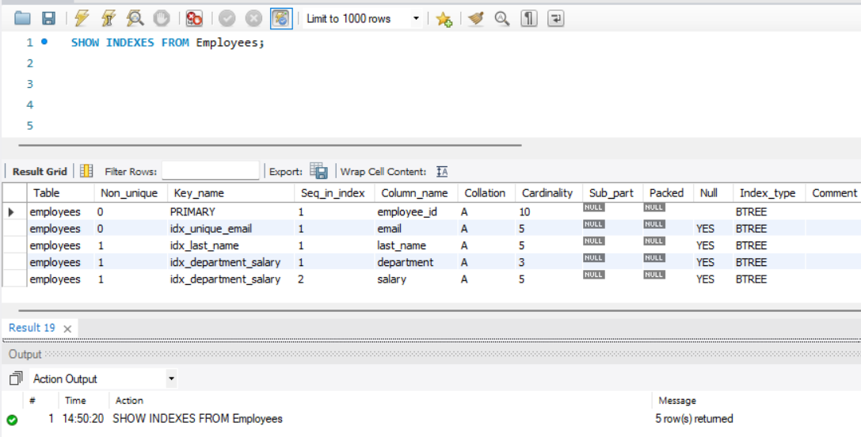

Output:
The queries was successfully executed

